Spectral coherence: NZDUSD and USDCHF
Method 21 / daily log returns / Welch magnitude-squared coherence / Alpari D1 full available history

Study setup
Logical pair: NZDUSD , USDCHF
Broker symbols: NZDUSD_i , USDCHF_i
Snapshot: 2026-11-03_majors_alpari_D1
Timeframe: D1
Matched return window: 1999-01-05 to 2026-11-02 (UTC bar dates)
Matched return count n: 7185
Dropped unfinished last bar dated 2026-11-03 UTC after a tick-volume check against the prior complete day.
Welch: fs=1.0, nperseg=256, noverlap=128, window=hann, detrend=constant
Headline: gamma^2 nearest f=1/5; also 1/21 and 1/63
Complete matched rows (Excel): NZDUSD-USDCHF_Spectral_D1.xlsx
Complete matched rows (HTML table): NZDUSD-USDCHF_Spectral_D1_data.html

Method carried forward
Magnitude-squared spectral coherence gamma^2(f) measures shared linear power between matched daily log returns of close, ln(close_t / close_t-1), at each frequency f (cycles per day). Quotes are not inverted. Welch settings are frozen: fs=1, nperseg=256, noverlap=128, window=hann, detrend=constant. Headline is gamma^2 at the frequency bin nearest f=1/5 (five-day cycle from the formula sheet). Also reported: gamma^2 nearest f=1/21 and f=1/63, mean gamma^2 over the frequency grid, and phase of the cross-spectrum at the 1/5 bin. Coherence is unsigned (0 to 1); phase carries timing. Same-sample Pearson r is a side check only. This is not causation and not a trading signal.

Results (headline)
gamma^2 near 1/5: 0.176738
bin f (1/5): 0.199219
phase at 1/5 (rad): 2.833808
gamma^2 near 1/21: 0.204246
gamma^2 near 1/63: 0.323452
mean gamma^2: 0.184311
Pearson r: -0.393600

Target-frequency summary
period | target_f | f_bin | gamma2 | phase_rad
5 | 0.2 | 0.19921875 | 0.17673798 | 2.8338081
21 | 0.04761905 | 0.046875 | 0.2042458 | 2.8270261
63 | 0.01587302 | 0.015625 | 0.32345192 | -3.0380973

Conclusion
Headline gamma^2 near f=1/5 for NZDUSD and USDCHF: 0.1767 (bin f=0.199219, phase=2.8338 rad). At ~1/21: 0.2042; at ~1/63: 0.3235. Mean gamma^2 = 0.1843. Pearson r = -0.3936. This is frequency-domain linkage, not a trading signal.

Charts
Daily closes

Daily log returns

Spectral coherence gamma^2(f)
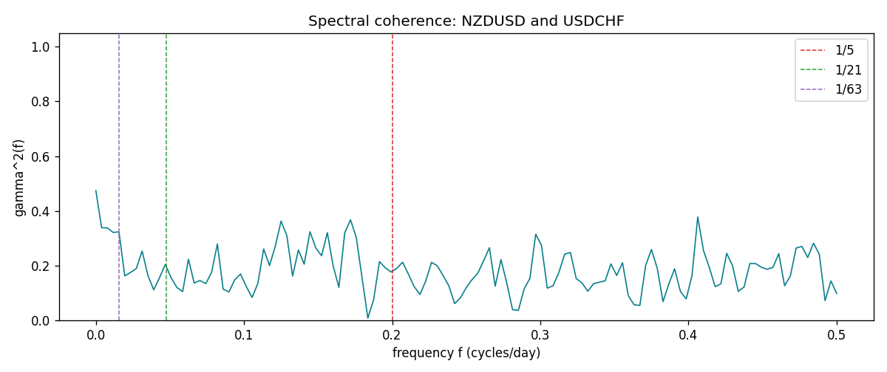

Data report
Matched rows and the coherence sheet are in the sibling Excel workbook named NZDUSD-USDCHF_Spectral_D1.xlsx. Embedding all rows as a Word table is impractical; this file holds column summaries and the first and last 15 matched rows.
Columns: time, NZDUSD_open, USDCHF_open, NZDUSD_high, USDCHF_high, NZDUSD_low, USDCHF_low, NZDUSD_close, USDCHF_close, NZDUSD_tick_volume, USDCHF_tick_volume, NZDUSD_spread, USDCHF_spread, NZDUSD_real_volume, USDCHF_real_volume, NZDUSD_log_return, USDCHF_log_return
Column summaries (matched calculation rows)
column | count | mean | std | min | 25% | 50% | 75% | max
NZDUSD_open | 7185 | 0.65641395 | 0.10821881 | 0.3913 | 0.59137 | 0.6684 | 0.72499 | 0.88218
USDCHF_open | 7185 | 1.0976269 | 0.25248305 | 0.72022 | 0.92053 | 0.98988 | 1.2378 | 1.8219
NZDUSD_high | 7185 | 0.66033247 | 0.10871106 | 0.3961 | 0.59478 | 0.672 | 0.72937 | 0.88421
USDCHF_high | 7185 | 1.1029176 | 0.25422469 | 0.73305 | 0.92474 | 0.99353 | 1.2423 | 1.8313
NZDUSD_low | 7185 | 0.65272894 | 0.10781325 | 0.3897 | 0.58811 | 0.66417 | 0.72099 | 0.87988
USDCHF_low | 7185 | 1.0925083 | 0.25089773 | 0.08565 | 0.91719 | 0.98622 | 1.2317 | 1.8121
NZDUSD_close | 7185 | 0.65649284 | 0.10821292 | 0.3907 | 0.59165 | 0.6684 | 0.72502 | 0.8822
USDCHF_close | 7185 | 1.0976163 | 0.25237603 | 0.72025 | 0.92079 | 0.98995 | 1.2379 | 1.8217
NZDUSD_tick_volume | 7185 | 68718.644 | 123140.12 | 16 | 5587 | 33899 | 58511 | 1127682
USDCHF_tick_volume | 7185 | 74335.19 | 113494.16 | 18 | 12810 | 40241 | 70443 | 858589
NZDUSD_spread | 7185 | 30.278775 | 25.647496 | 0 | 9 | 17 | 40 | 80
USDCHF_spread | 7185 | 26.036326 | 24.697816 | 0 | 5 | 16 | 50 | 100
NZDUSD_real_volume | 7185 | 1.6703703e+10 | 8.4983725e+10 | 0 | 0 | 0 | 0 | 2.705649e+12
USDCHF_real_volume | 7185 | 2.3294091e+10 | 8.9133595e+10 | 0 | 0 | 0 | 0 | 1.9331921e+12
NZDUSD_log_return | 7185 | 2.019e-05 | 0.00763908 | -0.07027433 | -0.0042485 | 0.00023717 | 0.00458461 | 0.05966839
USDCHF_log_return | 7185 | -7.205e-05 | 0.00658891 | -0.19545699 | -0.0033516 | 8.095e-05 | 0.00331593 | 0.09051364
First 15 matched rows (selected columns)
time | NZDUSD_log_return | USDCHF_log_return
1999-01-05 | -0.0018597736 | 0.0039424743
1999-01-06 | 0.0020455609 | 0.013605652
1999-01-07 | 0.0062963171 | -0.0093883841
1999-01-08 | -0.00055396548 | 0.011040268
1999-01-11 | 0.010290425 | 0.0052963193
1999-01-12 | -0.0053157489 | -0.0098275602
1999-01-13 | -0.0099742238 | -0.018259701
1999-01-14 | -0.00018564931 | -0.0024256692
1999-01-15 | -0.00074294208 | 0.01794228
1999-01-18 | -0.0018597736 | -0.0031856384
1999-01-19 | 0.0018597736 | -7.2518946e-05
1999-01-20 | 0.0040793678 | 0.0072259871
1999-01-21 | 0.0040627941 | -0.0038232689
1999-01-22 | -0.012051689 | -0.0001445609
1999-01-25 | -0.0035504102 | 0.0024546976
Last 15 matched rows (selected columns)
time | NZDUSD_log_return | USDCHF_log_return
2026-10-13 | 0.0047326165 | -0.0024955621
2026-10-14 | -0.0037306483 | 0.0029388325
2026-10-15 | 0.0047634855 | -0.0097855323
2026-10-16 | 0.0057501001 | -0.0036230826
2026-10-19 | 0.0018917133 | 0.0036351779
2026-10-20 | 0.0037199341 | -0.0026281224
2026-10-21 | 0.0030923331 | -0.00040027413
2026-10-22 | -0.0033035227 | -0.0048036381
2026-10-23 | 0.0030929853 | 0.005652514
2026-10-26 | -0.0028993932 | 0.0018407959
2026-10-27 | -0.00026399852 | 0.0026100526
2026-10-28 | -0.0097283914 | -0.0010142111
2026-10-29 | 0.00062190714 | -0.0048680164
2026-10-30 | 0.00019537668 | 0.00071594559
2026-11-02 | -0.0025962955 | -0.0071459744
First 15 frequency bins
f | gamma2 | phase_rad | period_days
0 | 0.47465502 | 3.1415927 | inf
0.00390625 | 0.33891587 | 3.1380691 | 256
0.0078125 | 0.33775726 | 2.9596615 | 128
0.01171875 | 0.32151549 | 3.046248 | 85.333333
0.015625 | 0.32345192 | -3.0380973 | 64
0.01953125 | 0.16274054 | -3.0204358 | 51.2
0.0234375 | 0.17535097 | -3.0206134 | 42.666667
0.02734375 | 0.18984132 | 3.0006105 | 36.571429
0.03125 | 0.25342144 | 2.980115 | 32
0.03515625 | 0.16422492 | -3.1389308 | 28.444444
0.0390625 | 0.11175241 | 3.0169362 | 25.6
0.04296875 | 0.15596516 | -3.1077742 | 23.272727
0.046875 | 0.2042458 | 2.8270261 | 21.333333
0.05078125 | 0.1561248 | 2.6906592 | 19.692308
0.0546875 | 0.1203256 | 3.0477717 | 18.285714

